**How To: Use Direct Line App Service Extension within a VNET**

This guide describes how to use the Direct Line App Service Extension with an Azure Virtual Network (VNET).

***Create an App Service Environment and other Azure resources***

1. Direct Line App Service Extension is available on all Azure App Services, including those hosted within an Azure App Service Environment. An Azure App Service Environment provides isolation and is ideal for working within a VNET.
   1. Instructions for creating an external App Service Environment are [here](https://docs.microsoft.com/en-us/azure/app-service/environment/create-external-ase).
   2. Instructions for creating an internal App Service Environment are [here](https://docs.microsoft.com/en-us/azure/app-service/environment/create-ilb-ase).
2. Once you have created your App Service Environment, you need to add an App Service Plan inside of it where you can deploy your bots (and thus run Direct Line App Service Extension). To do this:
   1. Go to <https://portal.azure.com/>
   2. Create a new “App Service Plan” resource.
   3. Under Region, select your App Service Environment
   4. Finish creating your App Service Plan

***Configure the VNET’s Network Security Groups (NSG)***

1. Direct Line App Service Extension requires an outbound connection so that it can issue HTTP requests. This can be configured as an outbound rule in your VNET’s NSG that is associated with the App Service Environment’s subnet. The rule that is required is:

|  |  |
| --- | --- |
| **Source** | Any |
| **Source Port** | * |
| **Destination** | IP Addresses |
| **Destination IP addresses** | 52.155.168.246,13.83.242.172 |
| **Destination port ranges** | 443 |
| **Protocol** | Any |
| **Action** | Allow |

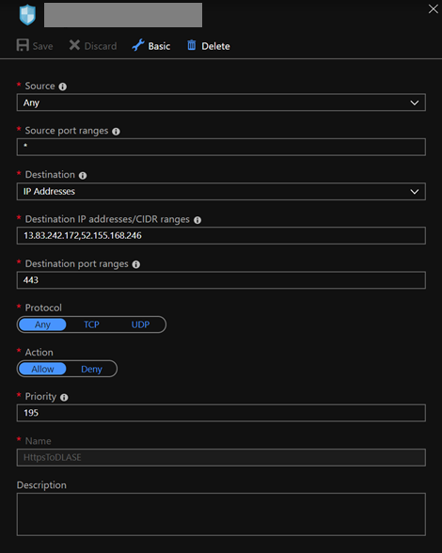

**Note**: The IP addresses provided are explicitly for the preview. We will be moving to a Service Tag for Azure Bot Service later in the year which will change this configuration.

***Configure your bot’s App Service***

1. For the preview, you will need to change how your Direct Line App Service Extension communicates with Azure. This can be done by adding a new App Service Application Setting to your application (via the portal, or via an applicationsettings.json file):

**Property:** DirectLineExtensionABSEndpoint

**Value:** https://dlase.botframework.com/v3/extension

**Note:** This will only be required for the preview of Direct Line App Service Extension.